Ex. No.: 3 Date:11/09/2015
Design of Half – Adder and Full – Adder circuits

Aim:
To understand the working of half-adder and full-adder circuits using Pspice and plotting the graph

Apparatus/Tool required:
ORCAD / PSpice simulator - > 7400 Library – 7408, 7432 & 7486
Source Library - Digclock
Simulation Settings: Analysis Type - Time Domain
Run to time: 4ms (for Half Adder)
Run to time: 8ms (for Full Adder)
Circuit Diagram:

Half – Adder Circuit

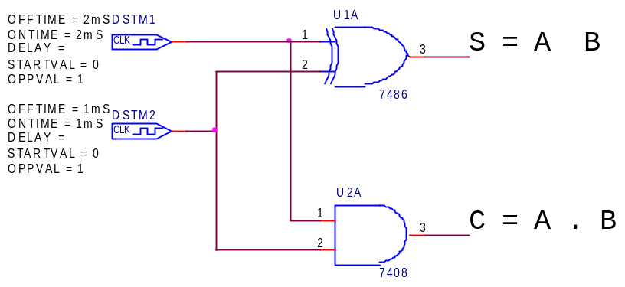
⊕

Full – Adder Circuit

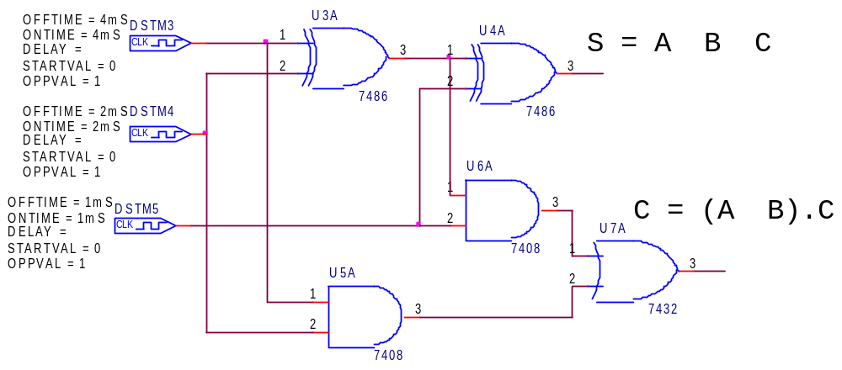
⊕

⊕

⊕

+ A·B

Theory:

Half Adder Circuit: Truth Table

Half adder is a combinational arithmetric circuit
A | B | S=A⊕B | C=A.B
0 | 0 | 0 | 0
0 | 1 | 1 | 0
1 | 0 | 1 | 0
1 | 1 | 0 | 1

That adds two numbers and produces a sum bit (S)
and a carry bit (C) as the output. If A and B are the
input bits, then sum bit (S) is the XOR of A and B
and the carry bit (C) is the AND of A and B.

Half adder circuit can be easily constructed by
using an XOR gate and one AND gate. It is the
simplest adder of all circuits.

Model Timing Diagram:

Half – Adder
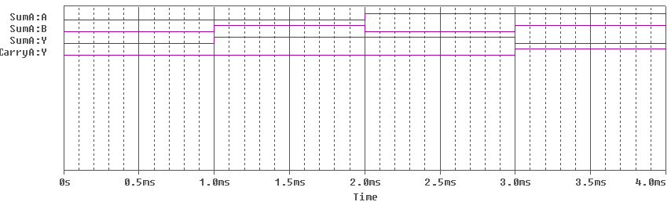

Full Adder Circuit Truth Table
A | B | C | S=A⊕B⊕B | C= (A⊕B).C+A.B
0 | 0 | 0 | 0 | 0
0 | 0 | 1 | 1 | 0
0 | 1 | 0 | 1 | 0
0 | 1 | 1 | 0 | 1
1 | 0 | 0 | 1 | 0
1 | 0 | 1 | 0 | 1
1 | 1 | 0 | 0 | 1
1 | 1 | 1 | 1 | 1

A full adder adds binary numbers and
accounts for values carried in as well
as out. A one bit full adder adds 3
one bit numbers A,B and C. A and B
are the operands and C is a bit carried
in from the previous stage. The
circuit produces two-bit output,
output carry C and sum S. A full
adder can be constructed from 2 half
adders.

Model Timing Diagram:

Full – Adder
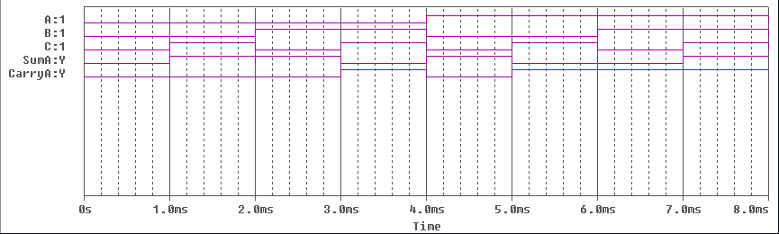

Procedure:

1) Create a blank project in capture CIS.
2) For half adder, place two square wave sources (Digiclock), an XOR gate (7486) and an AND gate.
3) For full adder, place 3 square wave sources (Digiclock), 2 XOR gates (7486), 2 AND gates (7408) and an OR gate (7432).
4) Place the parts as given in the representative circuit diagrams and connect them with wires.
5) Place voltage markers at input and output.
6) Create a new simulation program for Time Domain Analysis with run time as 4 ms for half adder and 8 ms for full adder.
7) Create and run simulation, record observations.

Result:
The half adder and full adder circuits have been designed and simulated using pSpice simulator. The graphs have been plotted for the same.

Inference:

The half adder adds only 2 bits and the carry from any previous addition is neglected.
The full adder adds 2 bits and the carry from previous addition. Hence the full adder is better than half adder.

